**User Documentation**

*Junyi Zhang, Rebecca Gu, Dejia Su*

*May 2018*

**Overview**

The Automation program has two different parts. The first part serves for cleaning, combining and calculating alternation statistics from the data templates and raw data exported from the eye-tracking device. This process can help researchers clean the data in an efficient and convenient way so that they can understand data better and spend time on valuable things instead of copying and pasting.

The second part serves for creating alternation plots either by participant or by trial in a given version. This process can help researchers visualize how the participant switch the fixations among different AOIs.

The program is tested under both Mac OS and Windows OS. The most updated version of this program could be found at [GitHub](https://github.com/JunyiZhang/statisticalPractice) or CMU box.

**Installment**

In order to use the Automation program, you need to have R and Rstudio ready on your computer. R is a free software environment for statistical computing and graphics while Rstudio is the IDE for R. R can be downloaded [here](https://www.r-project.org/), and Rstudio can be downloaded [here](https://www.rstudio.com/). Both softwares support Windows, Mac and Linux. After you download the both software, the Automation folder could be put anywhere you like.

**What is inside?**

The folder has two different components. The first part is two R script files called data_cleaning.R and alt_plots.R. As suggested by the name, data_cleaning.R is used to clean the data while alt_plots.R is used to create the alternation plots. You only need to open the corresponding file depends on your needs. The second part is a folder called functions. It contains all the functions needed to clean the data or create the plots. In general, there is no need to even open that folder unless you are curious.

**Part I: Data Cleaning**

**How to Use**

1. Open the data_cleaning.R using Rstudio.
2. Source the whole file by clicking the [**source**] bottom.

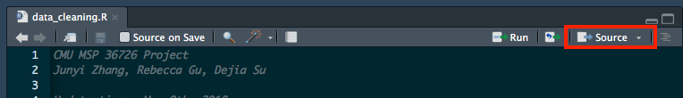

1. The program will start asking questions regarding the data. You should enter the answer in console and hit enter after typing the answer.

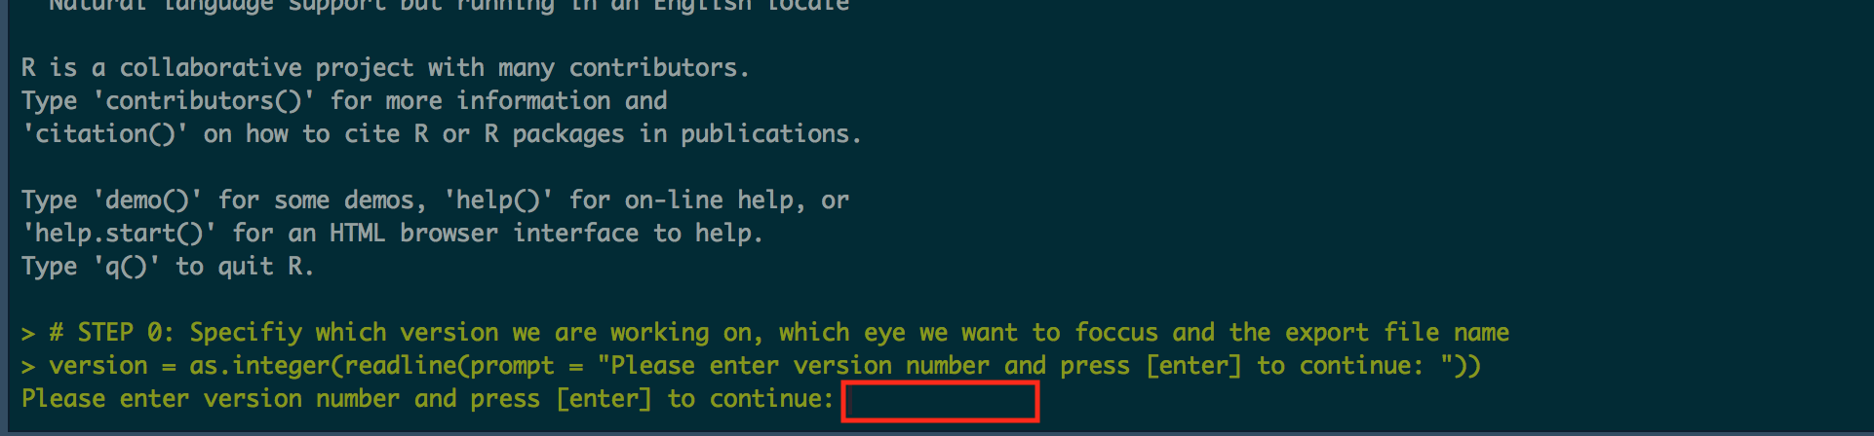

The questions are listed as following:

* 1. Please enter version number and press [enter] to continue: The answer should be a number indicating the version, e.g. 1.
  2. Please enter eye we want to focus (left or right) and press [enter] to continue: The answer should be left or right. The specified eye will be used to calculate the alternation statistics in raw data.
  3. Please enter the export file name (without extension) and press [enter] to continue: The answer should be the desired export file name, e.g. version 1.
  4. Please enter last trial for the first condition and press [enter] to continue: The answer should be an integer indicating the last trial of the first condition. E.g., in version 1, trial 1 to 4 is standard condition while trial 5 to 12 is fully separated. The answer in this case should be 4.
  5. Please enter the first condition name and press [enter] to continue: The answer should be the name of the first condition in the version specified above. E.g., the first four trials in version 1 is standard. The answer should be standard.
  6. Please enter the second condition name and press [enter] to continue: The answer should be the name of the second condition in the version specified above. E.g. the second 8 trials in version 1 is fully separated. The answer could be separated.

1. After all the questions are answered, the program will print all the information you entered and asks you to check if everything is correct. Hit enter if all of them are correct and program will continue. If you found any information entered is wrong, type ‘stop’(or anything other than blank) and hit [enter]. Program will stop and you can click source to restart the process.
2. In this step, you need to choose all the required datasets for automation process. The program will first specify the desired dataset name. After you hit enter, a dialogue box will pop, and then you can choose the desired dataset. Each dataset in this step must contain all the required variables. They are listed in the Appendix 1.
3. After all the datasets are chosen and loaded, the script will run automatically. Three csv files will be produced in the end and will be stored in a folder called **Output Data**.
   1. The long clean data named file_name.csv. The file_name is specified in step 3 part c. This file contains all the statistics in data templates and alternation statistics. Each row corresponds to one participant in one trial.
   2. The condition 1 summary data named version_number_cond1.csv. The version number and condition is specified in step 3 part a and e. This files contains average statistics for each participant in condition 1, where each row corresponds to one participant.
   3. The condition 2 summary data named version_number_con2.csv. The version number and condition is specified in step 3 part a and f. This files contains average statistics for each participant in condition w, where each row corresponds to one participant.

A detailed list of variables in each csv files are listed in Appendix 2.

**Part II: Alternation Plots**

**How to Use**

1. Open the alt_plots.R
2. Source the whole file by clicking the [**source**] bottom.
3. The program will start asking questions regarding the data. You should enter the answer in console and hit enter after typing the answer.

The questions are listed as follows:

* 1. Please enter version number and press [enter] to continue: The answer should be a number indicating the version, e.g. 1
  2. Please enter eye we want to focus (left or right) and press [enter] to continue: The answer should be left or right. The specified eye will be used to create the alternation plots.

1. In this step, you will be asked to choose which type of the plot you want to create. There are three choices:
   1. plot contains all trials(page) for one participant
   2. plot contains all the participants for one trial(page)
   3. both

An example of choice a is

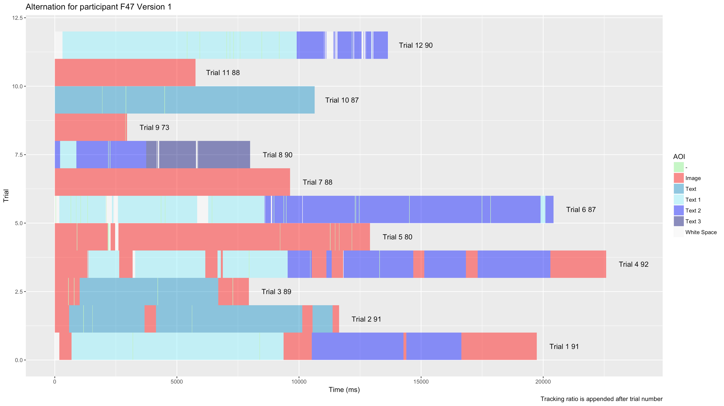

An example of choice b is

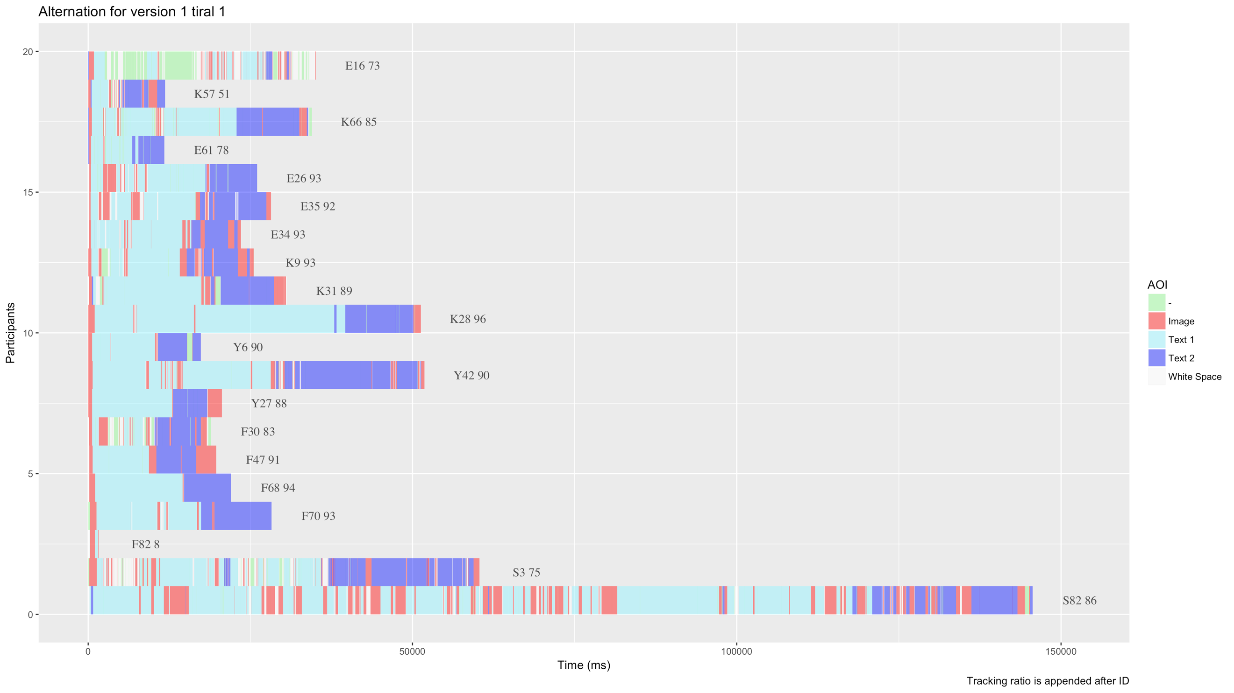

1. In this step, you need to choose the raw data. The program will first print prompt that asks you to choose. After you hit enter, a dialogue box will pop, and then you can choose the raw dataset.
2. After all the questions are answered and the raw data is loaded, the program will start to run while printing the progress. Once the you see finished, the whole process is done. A new folder will be created named version v, where v is specified in step 3 part a. Within version v, one or two subfolders will be created depends on your choice of part 4. One folder is named version v Trials. It contains all the alternations plots, where each plot contains all the participants for that trial. The other one is named version v Participants. It contains all the alternations plots, where each plot contains all the trials for that participant.

**Remark**:

* The program may take a relatively long time to run for the first time since R need to download and install all the required package. The run time should reduce significantly afterwards.
* Some of warnings are okay such as a certain package is built under a different version of R. In general, it does not affect the usage of the program. Updating R periodically could resolve this issue.
* It is okay for datasets to contain variables that is not required. The program will ignore all the unrecognized variables. However, missing variables will cause an error and a message should be given.
* The alternation statistics and alternation plots only focus on the shift of AOI fixation of a specific eye. i.e. the shift of from fixation on text to fixation on image will count as one shift from text to image. However, the shift from fixation on text to blink does not count.
* The number appended after the trial number or participant ID in alternation plot is the tracking ratio.

**Appendix 1 – Required variables in each dataset**

* AOI Blanks
  + Trial
  + Stimulus
  + Participant
  + AOI Name
  + Fixation Count
  + Fixation Time [ms]
  + Fixation Time [%]
* AOI Fixations
  + Trial
  + Stimulus
  + Participant
  + AOI Group
  + Fixation Count
  + Fixation Time [ms]
  + Fixation Time [%]
* Fixation, saccades and blink counts
  + Trial
  + Stimulus
  + Participant
  + Fixation Count
  + Fixation Duration Total [ms]
  + Saccade Count Saccade Duration Total [ms]
  + Saccade Amplitude Total [°]
  + Saccade Velocity Total [°/s]
  + Blink Count
* Trial Duration
  + Stimulus
  + Trial Duration [ms]
  + Participant
  + Tracking Ratio [%]

**Appendix 2 – List of Variables in output file**

* The long clean data

|  |  |
| --- | --- |
| Variable | Comment |
| Participant |  |
| Stimulus |  |
| Trial_dur | Trial duration in ms |
| Tracking_ratio |  |
| Trial |  |
| Blank_fix_count | Blank fixation count |
| Blank_fix_time | Blank fixation time |
| Blanks_fix_time_pct | Blank fixation time percent |
| Image_fix_count | Image fixation count |
| Image_fix_time | Image fixation time |
| Image_fix_time_pct | Image fixation time percent |
| Text_fix_count | Text fixation count |
| Text_fix_time | Text fixation time |
| Text_fix_time_pct | Text fixation time percent |
| Fix_count | Fixation count |
| Total_fix_dur | Total fixation duration |
| Saccade_count |  |
| Total_saccade_dur | Total saccade duration |
| Total_saccade_amp | Total saccade amplitude |
| Total_saccade_velocity |  |
| Blink_count |  |
| Condition |  |
| max_text_time | Single max text fixation duration |
| ws_Text | Alternation from white space to text count |
| ws_Image | Alternation from white space to image count |
| ws_dash | Alternation from white space to dash count |
| Text_Image | Alternation from text to image count |
| Text_ws | Alternation from text to white space count |
| Text_dash | Alternation from text to dash count |
| Image_Text | Alternation from image to text count |
| Image_ws | Alternation from image to white space count |
| Image_dash | Alternation from image to dash count |
| dash_Image | Alternation from dash to image count |
| dash_Text | Alternation from dash to text count |
| dash_ws | Alternation from dash to white space count |
| weighted_text_image | Weighted alternation from text to image count * |
| weighted_image_ws | Weighted alternation from image to white space * |
| weighted_alt | Weighted alternation count * |
| total_alt | Total alternation count |
| Version |  |

* Weighted means we put more weight on alternation at the beginning of each trial and put less weight on alternation at the end of trial. The alternation at time 0 will have weight of 1 and alternation at the end of trial will have weight of 0. The weight decrease at a constant rate. It means the alternations at the beginning of each trial have much more influence on reading pattern than the alternations at the end of each trial do.

* Condition Summary Data

|  |  |
| --- | --- |
|  |  |
| Variables | Comment |
| Participant |  |
| Avg_trial_dur | Average trial duration |
| Avg_blank_fix_count | Average blank fixation count |
| Avg_blank_fix_time | Average blank fixation time |
| Avg_blank_fix_time_pct | Average blank fixation time percent |
| Avg_image_fix_count | Average image fixation count |
| Avg_image_fix_time | Average image fixation time |
| Avg_image_fix_time_pct | Average image fixation time percent |
| Avg_text_fix_count | Average text fixation count |
| Avg_text_fix_time | Average text fixation time |
| Avg_text_fix_time_pct | Average text fixation time percent |
| Avg_fix_count | Average fixation count |
| Avg_total_fix_dur | Average total fixation duration |
| Avg_saccade_count | Average saccade count |
| Avg_total_saccade_dur | Average total saccade duration |
| Avg_total_saccade_amp | Average total saccade amplitude |
| Avg_total_saccade_velocity | Average total saccade velocity |
| Avg_blink_count | Average blink count |
| Avg_ws_Text | Average alternation from white space to text count |
| Avg_ws_Image | Average alternation from white space to image count |
| Avg_ws_dash | Average alternation from white space to dash count |
| Avg_Text_Image | Average alternation from text to image count |
| Avg_Text_ws | Average alternation from text to white space count |
| Avg_Text_dash | Average alternation from text to dash count |
| Avg_Image_Text | Average alternation from image to text count |
| Avg_Image_ws | Average alternation from image to white space count |
| Avg_Image_dash | Average alternation from image to dash count |
| Avg_dash_Image | Average alternation from dash to image count |
| Avg_dash_Text | Average alternation from dash to text count |
| Avg_dash_ws | Average alternation from dash to white space count |
| Avg_total_alt | Average total alternation count |
| Avg_weighted_text_image | Average weighted alternation from text to image |
| Avg_weighted_image_ws | Average weighted alternation from image to white space |
| Avg_weighted_alt | Average weighted alternation count |
| Version |  |